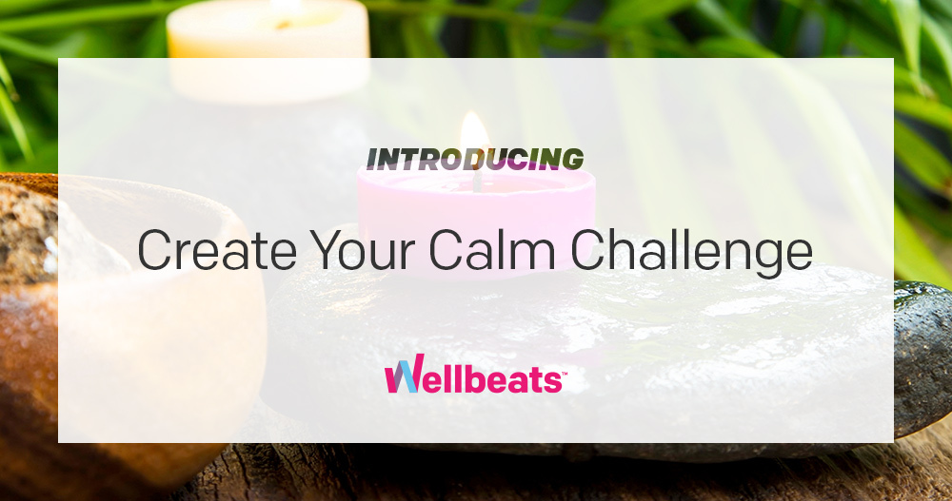

May is Mental Health Awareness Month. It is a way for us to honor those who struggle with mental health issues while learning how to find ways to better manage our own stress.

Starting May 10th – 23rd the Getty Fitness Center invites you to join a Wellbeats* 2-week “Create Your Calm” challenge, including a day-by-day schedule of mindfulness and meditation classes to help you pause, breathe, and create calm. No equipment necessary.

Sign up for the challenge by contacting fitnesscenter@getty.edu (or reach out for more info).

* Wellbeats is your free, on-demand fitness and wellbeing benefit.

